Creative Brief
-----------------------------------------------------------------------------------------------------------------------------
DESCRIPTION: Oatly’s Oat Cheese Advertising Campaign
PREPARED BY: Claire Yim
-------------------------------------------------------------------------------------------------------------------------------
Why do this project?
Oatly is doing this project to promote the release of its new oat-based cheese. This North American campaign will outline Oatly’s new vegan cheese alternative in a market that is currently lacking a mainstream oat-based cheese alternative. Through this campaign, we want our audience to believe that Oatly’s Oat Cheese is the go-to vegan cheese alternative that outperforms and is more sustainable than traditional dairy cheese.

What problem are you trying to solve and/or opportunity are you trying to capitalize on?
An opportunity that Oatly is trying to capitalize on is the lack of oat-based cheese in the plant-based cheese market. Most mainstream vegan cheeses are often made with a wide range of ingredients including soy, cashew, coconut oil and other natural ingredients but none that are made from oats. As a result, Oatly would be the first “mainstream” brand to release an oat cheese in the retail market, beating its biggest competitors Chobani and Planet Oat.

Who are you trying to influence/target?
Oatly is targeting individuals between the ages of 22 to 35 that are employing a dairy-free or vegan diet. Or, our target audience may have a traditional diet but are interested in trying plant-based cheese alternatives. This audience is also more eco-conscious and carefully monitors the ingredients that are in their foods.

What is the one primary message you want to send?
Oatly’s Oat Cheese is better than dairy cheese.

Why should the primary audience care?
The primary audience should care because there is now a new vegan cheese option for individuals that do not enjoy consuming traditional cashew- or soy-based cheese. With Oatly’s new oat cheese, our audience can enjoy cheese in their diet without having to resort to animal-produced cheese.

What’s in it for them? How will they benefit from what you have to say?
The primary audience will benefit by getting to enjoy a new plant-based cheese option in their diet. This audience will also be reassured by the fact that they are consuming a more environmentally sustainable cheese alternative.

What primary action do you want the target audience to take?
The primary action we want the target audience to take is to buy Oatly’s new oat cheese product.

What’s preventing the target audience from taking this action today?
There is a lack of oat cheese products in the vegan cheese market and none that are made by bigger food manufacturers with Oatly’s production scale. As a result, consumers have not tried oat cheese and are not familiar with the concept.

When is the ideal time period to drive behavioral change?
The ideal time to drive behavioral change is during World Vegan Day on November 1, 2024. The advertisement will be an announcement that makes consumers aware of a new oat-based cheese product.
To celebrate, our primary audience would be more inclined to try a new vegan product in time for World Vegan Day.

Where will this advertisement be placed?
True to Oatly’s unique advertising history, we will continue to employ OOH billboards in metropolitan cities such as London and New York on the side of buildings and at bus shelters. The OOH billboards will be easily visible for people walking on the streets. Please see below for Oatly’s previous advertising campaigns:
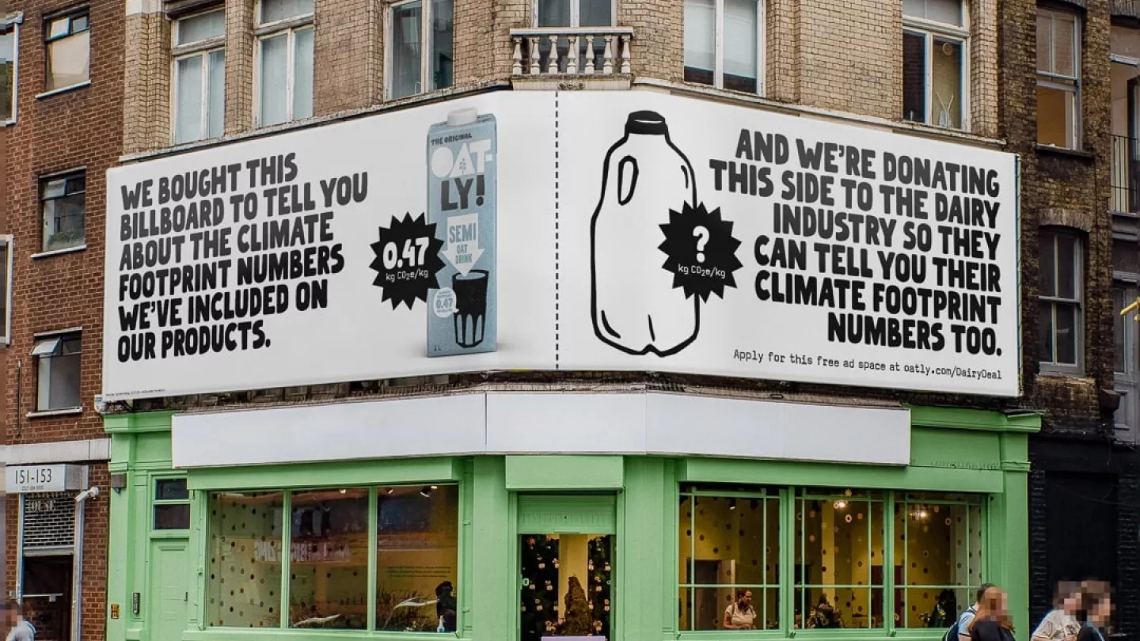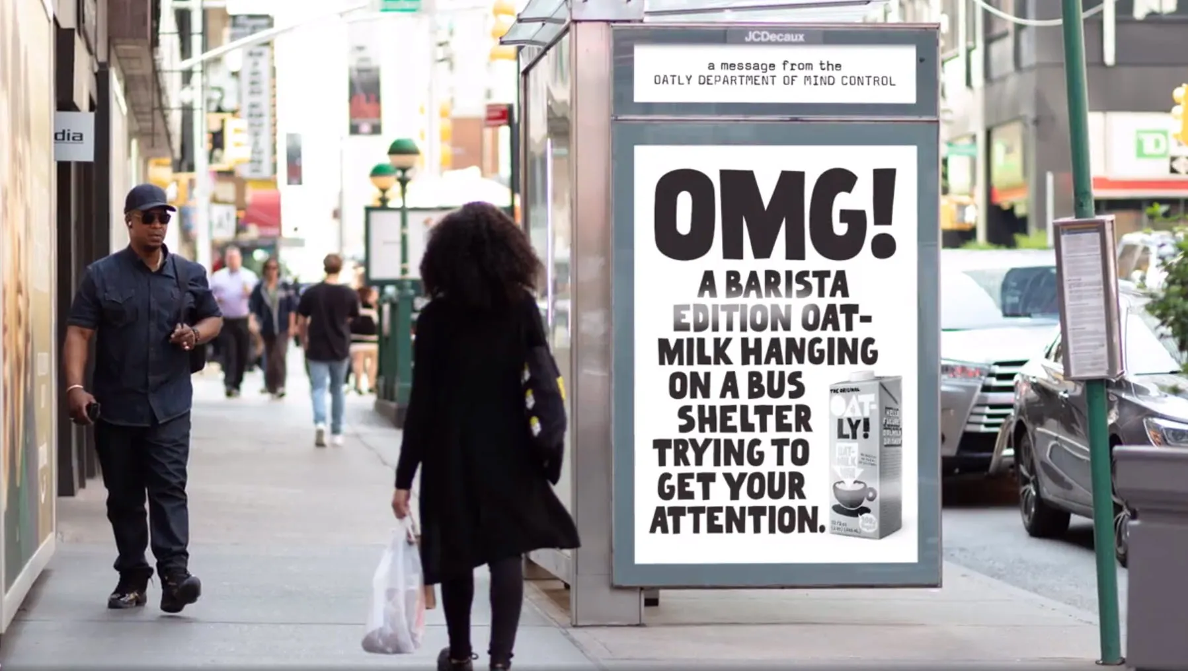

Tagline
“We take the g out of goat cheese.”
- The advertisement will then go on to list negative adjectives that start with the letter ‘g’ that is associated with animal-produced cheese including greasy, greedy and gassy. This is to highlight how Oatly’s Oat Cheese is better than goat cheese, and other dairy cheeses, by excluding negative outcomes or traits of animal-produced cheeses through the letter ‘g.’

